Government of Pakistan
Prime Minister Secretariat (Public)
Earthquake Reconstruction and Rehabilitation Authority (ERRA)
Islamabad

Date: 31 July, 2018
Press Release

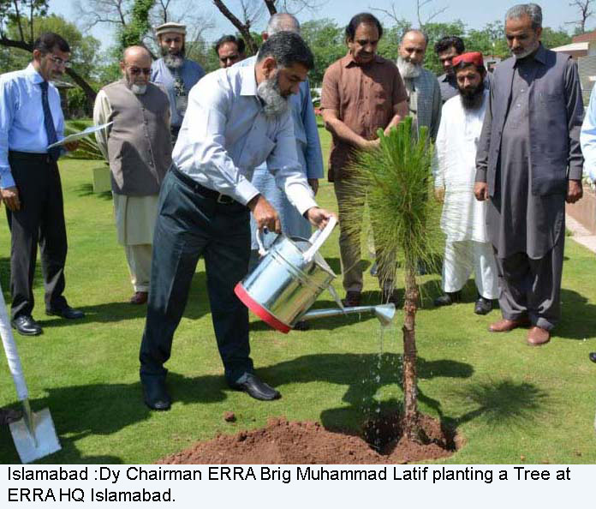

Climatic Changes Increase our Vulnerability to Natural Disasters: ERRA Deputy Chairman Brig Latif Instructs Tree plantation on all ERRA reconstructed educational and health projects in AJK and KP.

Pakistan like all South Asian Region is high on vulnerability to natural disasters following severe and unprecedented climatic change seen in the region in form of floods, landslides and frequent earth quake jolts. “To act preemptively for preparedness and effective response to natural disasters caused by floods and earthquake, we not only need to educate masses but also participate in drive to cultivate new plants” said Deputy Chairman Brig Latif in a meeting today. He also instructed administration to make tree plantation mandatory in all reconstructed schools, colleges, universities and health facilities in earthquake affected areas. The tree plantation drive started from ERRA HQ Islamabad where new trees were planted today. It is pertinent to mention that focusing on risk reduction and mass awareness ERRA has started a campaign targeting educational institutions in earthquake affected areas encouraging students and administration to plant new trees so that soil strength can withstand any unforeseen incidents in coming days by infusing a social civil responsibility spirit in younger generation.

